**Identification and Validation of Cell-free DNA Methylation Biomarker for Glioblastoma**

**Research Goal**

Glioblastoma (GBM) is a primary neuro-epithelial tumor characterized with extremely aggressive clinical phenotype and a poor prognosis. Early diagnosis to GBM is one of most effective approach to rise the 3-year survival ratio (from 1% to 20%). In my previous study, we shown high proliferation ratio and high death ratio of cancer cells provided large number of tissue-specific DNA methylation signals (10,000 copies/mL) which could be applied for mapping the cell-free DNA methylation signals to the tissue-of-origin of cancer organs. The overarching goal of this study is to identify and validate an early diagnostic biomarker panel for glioblastoma. Meanwhile, we will also investigate the earliest time when the cell-free DNA methylation can be detected before diagnosis and normal individuals with high genetic risks. The proposed study is highly significant and important, as the circulating cell free DNA methylation-based biomarkers will not only help clinicians to diagnose or surveillance disease progress, but also provide important clues to understand the pathogenic mechanisms of glioblastoma.

**Aim 1:** To identify and validate key circulating DNA methylation-based predictive biomarkers in PMRP well annotated glioblastoma samples.

**Aim 2:** To identify and validate key circulating DNA methylation-based predictive and prognostic biomarkers in PMRP well annotated glioblastoma samples.

**Aim 3:** To confirm the earliest time of the DNA methylation signals through checking the cell-free DNA methylation status to serums before diagnosis in PMRP glioblastoma samples.

**Aim 4:** To test the hypothesis that whether cell-free DNA methylation signals could be detected in high risk individuals who have high polygenic-risk-score.

**Public Health Relevance**

Circulating cell-free DNA methylation have been demonstrated to be most potential biomarkers for cancer early diagnosis and prognosis. Current, FDA have approved one DNA methylation early screening DNA methylation biomarker for colon cancer (*SEPT9*) and another methylation-based biomarker (*SHOX2*) for lung cancer is under-evaluation by FDA. However, DNA methylation biomarker for glioblastoma is still unknown. In this study, we will use huge DNA methylation dataset collected from The Cancer Genome Atlas (TCGA) project and Gene Expression Omnibus (GEO) database to identify the most potential methylation biomarkers for diagnosis and prognosis and then validated them in Marshfield Clinic Glioblastoma samples. Furthermore, we could make full use of longitudinal study design of PMRP to confirm the earliest time of DNA methylation signals before diagnosis and test the hypothesis whether high polygenic-risk-score individuals will have higher frequent abnormal methylation signals.

**Background**

Glioblastoma (GBM) is a primary neuro-epithelial tumor characterized with extremely aggressive clinical phenotype and a poor prognosis (5-year survival ratio of 8%). Early diagnosis to GBM is one of most effective approach to rise the 3-year survival ratio (from 1% to 20%). Currently, the most common diagnosis approach for glioblastoma is Magnetic resonance imaging (MRI), computerized tomography (CT) and biopsy, however, the high cost of MRI, radiation risk of provided tons of concerns from current clinical services. What’s more, MRI and CT cannot provide extra glioblastoma information such as glioma grading, subtype and prognostic measures. Biopsy could provide more information, however, it is invasive treatment and will bring extra risk for cancer metastasis. Molecular diagnosis have been becoming one of most important approaches to provide accurate diagnosis with fast speed and low-cost. Compared with other molecular variants such as SNPs, CNV, mRNA and miRNAs, DNA methylation have been proved to be most powerful biomarker for cancer diagnosis since its flexible stability. Genome-wide DNA hypo-methylation and locally hyper-methylation in the promoter region of tumor suppressor genes have been observed for all most all cancer types(1, 2) and these abnormal change have been demonstrated to be earlier than most symptoms(3, 4) which can be detected by MRI or CT(5-7). In our previous research, we found DNA methylation could be used to silence tumor suppressor genes(8, 9), miRNAs(10), mRNAs(11) and drug metabolic genes (12) to play roles in cancer development(13), metastasis(14) and chemotherapy resistance(15). Recently, we demonstrated that circulating cell-free DNA methylation could provide a novel approach to help the clinicians to diagnosis or predict cancers in an early stage and with a non-invasive way (16). What’s more, compared with mutations, DNA methylation have more biomarkers to be selected for diagnosis and prognosis. According to recently research, DNA methylation abnormal in individual cancer patients could come up to 103-104 while mutations (driver mutation and passenger mutation) is only 10-102 and therefore majority of the gene expression changes are caused by DNA methylation rather than mutation even that mutation and DNA methylation could work together to silence certain genes, such as TP53(17).

In the past decades, DNA methylation research in glioblastoma was very limited and mainly focus on several identified genes, such as MGMT (18, 19), CD133 (20), ARF1 (21) and mainly focus on prognosis. Several of non-coding RNA was also reported to be abnormal in GBM, such as miR-153(22), miR-181(23). Even though there were several genome-wide DNA methylation studies to identify differential DNA methylation (24-27), limited sample size make it difficult to make solid conclusion (24-30), especially normal controls are difficult to obtained. What’s more, there are only few study was conducted to do DNA methylation biomarkers for glioblastoma based on circulating cell-free DNA which might be caused by the worry from blood-brain barrier. I found 6 papers (31-36) in Pubmed with the [keywords](https://www.ncbi.nlm.nih.gov/pubmed/?term=((cell-free+or+circulating)+AND+glioblastoma)+AND+methylation) of cell-free or circulating, methylation and glioblastoma in all the field. Giselle and his colleagues found circulating cell-free DNA could be prognostic and molecular marker for brain tumor under Perillyl Alcohol-based therapy (37).

We also collected 516 lower grade glioma (LGG) and 1,198 normal PBMC genome-wide DNA methylation data to increase the power to identify GBM biomarkers.

In this study, we collected 2,462 genome-wide DNA methylation data (Illumina methylation 850K/450K/27K beadchip) for glioblastoma and more than 12,359 other cancer genome-wide DNA methylation dataset (HM450K). Meanwhile, the RNA-seq data are also available for these methylation dataset. Therefore, we can identify all the hyper-methylated genes which are low-expression in glioblastoma or hypo-methylated genes while high-expression in glioblastoma. We also collected more than 1,198 normal PBMC HM450 data which can be used to be background control to identify hyper-methylated DNA fragments which are non-methylated for blood cells so that we can obtain the most potential hyper-methylation biomarkers for glioblastoma in the blood and without the interference from blood cell DNA methylation signals.

**Preliminary Studies**

Genome-wide DNA methylation profile of glioblastoma revealed numerous DNA methylation biomarkers

Table 1. Dataset collected for the GBM methylation biomarker identification project

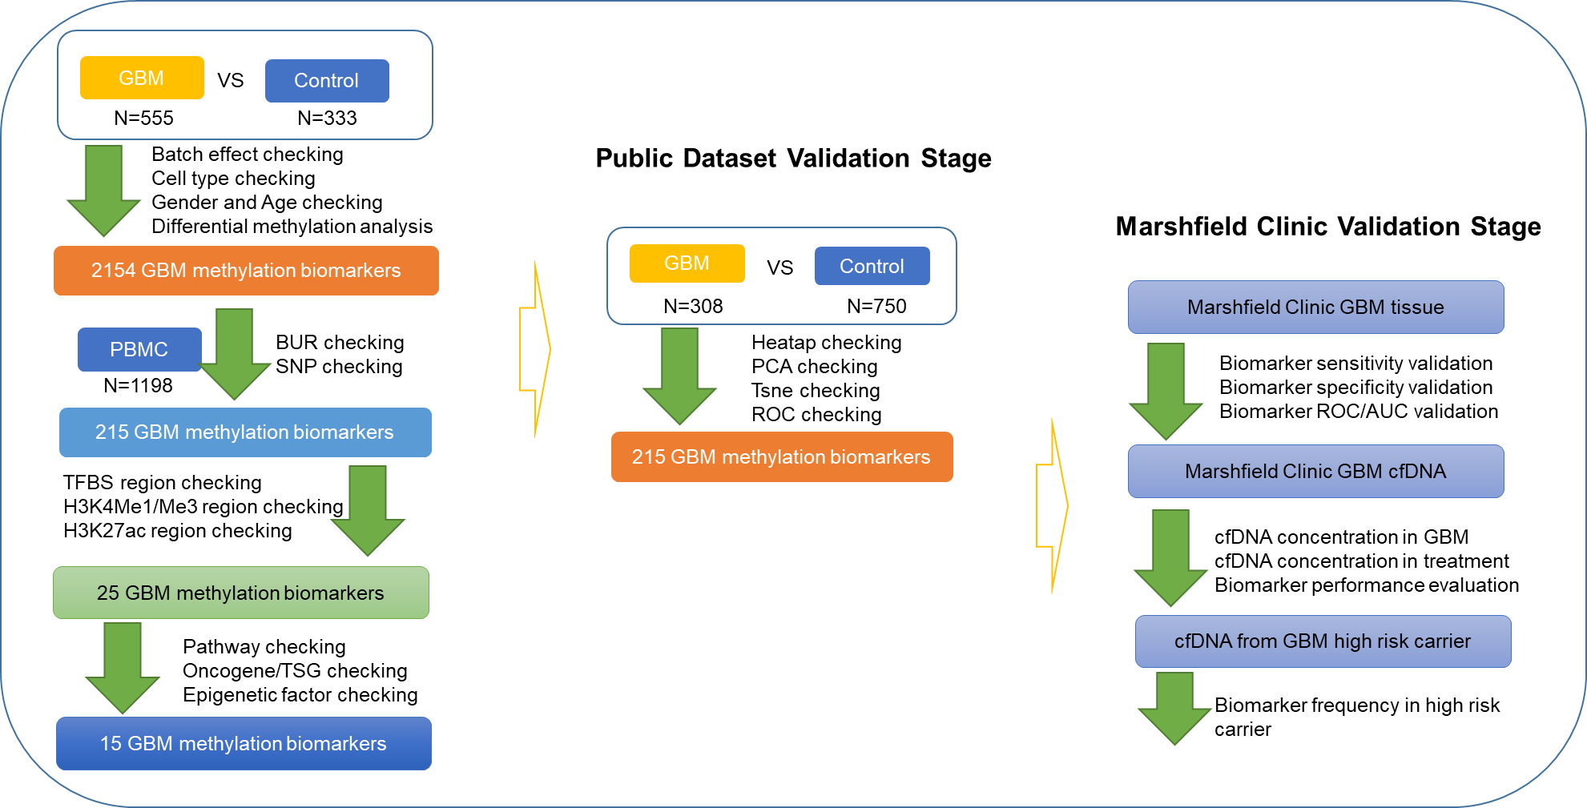

Figure 1. Flowchart of DNA methylation based biomarker for GBM. We applied multiple stage biomarker identification process to avoid false positive result and large-sample size to decrease the type-II error. In the discovery stage, we collected 555 GBM, 333 control brain and 1,198 normal PBMC to identify GBM related hyper-methylation biomarkers. We also require non-methylation status for these biomarkers in blood cells (PBMC) so that we can detect these methylation signal without strong noisy from background. Biomarkers which are significant associated with age, gender and overlap with SNPs are removed in the analysis. We also apply transcriptional factor binding site/region and main histone modification (H3K4me1, H3K4me3 and H3K27ac) as the filter to identify potential function methylation biomarkers. In the second stage, we validate these biomarkers in another independent dataset which include 308 GBM and 750 control brain.

**Power calculations**

Table 1. Public data collected in GBM methylation based biomarker project.

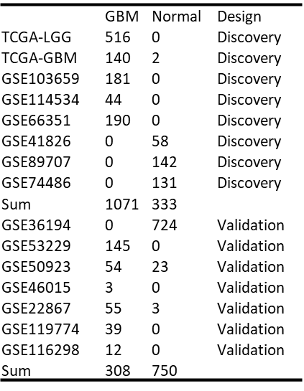

**Research Design and Methodology**

We removed 21 samples since these are blood-derived (from GSM1921566 to GSM1921586).

709 male and 565 female and 196 unknown gender samples

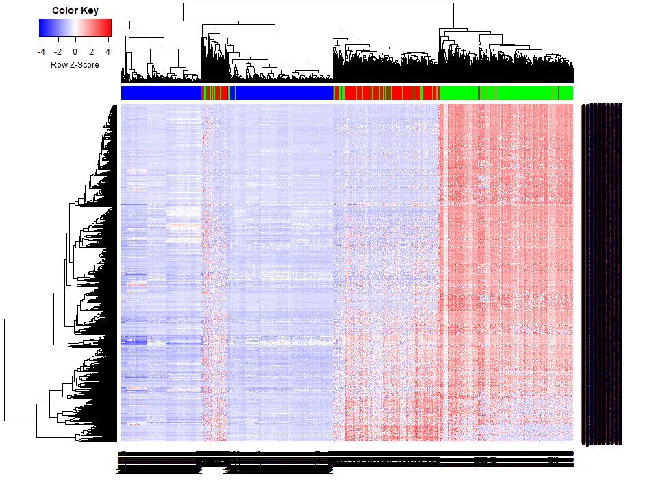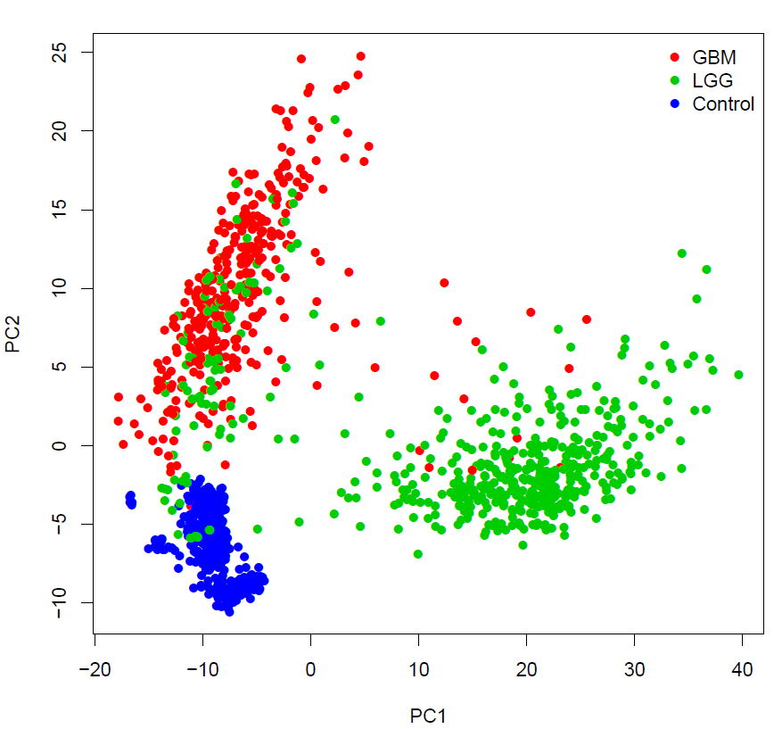

We

|  |  |  |  |  |  |  |  |  |
| --- | --- | --- | --- | --- | --- | --- | --- | --- |
| Term | Count | % | List Total | Pop Hits | Pop Total | FE | Benjamini | FDR |
| DNA-binding region: Homeobox | 53 | 4.15 | 1238 | 191 | 20063 | 4.50 | 6.43E-17 | 3.73E-17 |
| Homeobox | 61 | 4.78 | 1250 | 262 | 20581 | 3.83 | 3.09E-17 | 1.91E-16 |
| IPR017970:Homeobox, conserved site | 52 | 4.07 | 1199 | 190 | 18559 | 4.24 | 1.10E-15 | 1.07E-15 |
| IPR001356:Homeodomain | 61 | 4.78 | 1199 | 256 | 18559 | 3.69 | 6.23E-16 | 1.21E-15 |
| sequence-specific DNA binding | 89 | 6.97 | 1109 | 518 | 16881 | 2.62 | 1.22E-13 | 1.78E-13 |
| SM00389:HOX | 61 | 4.78 | 784 | 250 | 10057 | 3.13 | 3.51E-13 | 1.37E-12 |
| IPR009057:Homeodomain-like | 64 | 5.01 | 1199 | 336 | 18559 | 2.95 | 7.12E-12 | 2.08E-11 |
| DNA-binding | 197 | 15.43 | 1250 | 2050 | 20581 | 1.58 | 4.63E-09 | 5.72E-08 |
| transcriptional activator activity | 45 | 3.52 | 1109 | 236 | 16881 | 2.90 | 1.38E-07 | 4.01E-07 |
| Activator | 81 | 6.34 | 1250 | 661 | 20581 | 2.02 | 2.36E-07 | 3.65E-06 |
| Cell junction | 82 | 6.42 | 1250 | 675 | 20581 | 2.00 | 2.32E-07 | 4.29E-06 |
| Transcription regulation | 203 | 15.90 | 1250 | 2332 | 20581 | 1.43 | 3.57E-06 | 9.91E-05 |
| Homeodomain, metazoa | 23 | 1.80 | 1199 | 92 | 18559 | 3.87 | 2.78E-05 | 1.09E-04 |
| GO:0006366~transcription from RNA polymerase II promoter | 68 | 5.32 | 1122 | 513 | 16792 | 1.98 | 9.79E-05 | 1.70E-04 |
| Transcription | 205 | 16.05 | 1250 | 2398 | 20581 | 1.41 | 1.04E-05 | 3.21E-04 |
| transcription factor activity, sequence-specific DNA binding | 104 | 8.14 | 1109 | 961 | 16881 | 1.65 | 1.57E-04 | 6.85E-04 |
| LIM domain | 18 | 1.41 | 1250 | 72 | 20581 | 4.12 | 3.67E-05 | 0.001474 |
| IPR008253:Marvel | 12 | 0.94 | 1199 | 29 | 18559 | 6.40 | 3.15E-04 | 0.001536 |
| domain:MARVEL | 11 | 0.86 | 1238 | 26 | 20063 | 6.86 | 0.001274 | 0.002959 |
| DNA-binding region:T-box | 9 | 0.70 | 1238 | 16 | 20063 | 9.12 | 0.001048 | 0.003043 |
| Synapse | 46 | 3.60 | 1250 | 357 | 20581 | 2.12 | 8.97E-05 | 0.003878 |
| IPR001781:Zinc finger, LIM-type | 18 | 1.41 | 1199 | 72 | 18559 | 3.87 | 6.92E-04 | 0.00405 |
| IPR008967:p53-like transcription factor, DNA-binding | 14 | 1.10 | 1199 | 44 | 18559 | 4.93 | 6.19E-04 | 0.004225 |
| IPR001699:Transcription factor, T-box | 9 | 0.70 | 1199 | 17 | 18559 | 8.19 | 9.17E-04 | 0.007157 |
| IPR018186:Transcription factor, T-box, conserved site | 9 | 0.70 | 1199 | 17 | 18559 | 8.19 | 9.17E-04 | 0.007157 |
| short sequence motif:OAR | 8 | 0.63 | 1238 | 14 | 20063 | 9.26 | 0.004034 | 0.014075 |
| SM00425:TBOX | 9 | 0.70 | 784 | 17 | 10057 | 6.79 | 0.002943 | 0.022977 |
| SM00132:LIM | 18 | 1.41 | 784 | 72 | 10057 | 3.21 | 0.003196 | 0.037424 |
| sensory perception of sound | 24 | 1.88 | 1122 | 133 | 16792 | 2.70 | 0.006032 | 0.041904 |
| positive regulation of excitatory postsynaptic potential | 9 | 0.70 | 1122 | 20 | 16792 | 6.73 | 0.005964 | 0.044016 |
| mesenchymal to epithelial transition involved in metanephros morphogenesis | 6 | 0.47 | 1122 | 7 | 16792 | 12.83 | 0.005909 | 0.046171 |

**Timeline**

**Budget**

**Budget Justification**

**Literature Cited**

1. Feinberg AP, Vogelstein B. Hypomethylation distinguishes genes of some human cancers from their normal counterparts. Nature 1983;301:89-92.

2. Feinberg AP, Vogelstein B. Hypomethylation of ras oncogenes in primary human cancers. Biochem Biophys Res Commun 1983;111:47-54.

3. Brock MV, Hooker CM, Ota-Machida E, Han Y, Guo M, Ames S, Glockner S, et al. DNA methylation markers and early recurrence in stage I lung cancer. N Engl J Med 2008;358:1118-1128.

4. Fujiwara K, Fujimoto N, Tabata M, Nishii K, Matsuo K, Hotta K, Kozuki T, et al. Identification of epigenetic aberrant promoter methylation in serum DNA is useful for early detection of lung cancer. Clin Cancer Res 2005;11:1219-1225.

5. Han L, Kamdar MR. MRI to MGMT: predicting methylation status in glioblastoma patients using convolutional recurrent neural networks. Pac Symp Biocomput 2018;23:331-342.

6. Wei J, Yang G, Hao X, Gu D, Tan Y, Wang X, Dong D, et al. A multi-sequence and habitat-based MRI radiomics signature for preoperative prediction of MGMT promoter methylation in astrocytomas with prognostic implication. Eur Radiol 2019;29:877-888.

7. Jiang S, Rui Q, Wang Y, Heo HY, Zou T, Yu H, Zhang Y, et al. Discriminating MGMT promoter methylation status in patients with glioblastoma employing amide proton transfer-weighted MRI metrics. Eur Radiol 2018;28:2115-2123.

8. Jiang D, He Z, Wang C, Zhou Y, Li F, Pu W, Zhang X, et al. Epigenetic silencing of ZNF132 mediated by methylation-sensitive Sp1 binding promotes cancer progression in esophageal squamous cell carcinoma. Cell Death Dis 2018;10:1.

9. Lei Y, Liu L, Zhang S, Guo S, Li X, Wang J, Su B, et al. Hdac7 promotes lung tumorigenesis by inhibiting Stat3 activation. Mol Cancer 2017;16:170.

10. He Y, Cui Y, Wang W, Gu J, Guo S, Ma K, Luo X. Hypomethylation of the hsa-miR-191 locus causes high expression of hsa-mir-191 and promotes the epithelial-to-mesenchymal transition in hepatocellular carcinoma. Neoplasia 2011;13:841-853.

11. Lan Q, Liu PY, Haase J, Bell JL, Huttelmaier S, Liu T. The Critical Role of RNA m(6)A Methylation in Cancer. Cancer Res 2019.

12. Hegi ME, Diserens AC, Gorlia T, Hamou MF, de Tribolet N, Weller M, Kros JM, et al. MGMT gene silencing and benefit from temozolomide in glioblastoma. N Engl J Med 2005;352:997-1003.

13. Chae YC, Kim JY, Park JW, Kim KB, Oh H, Lee KH, Seo SB. FOXO1 degradation via G9a-mediated methylation promotes cell proliferation in colon cancer. Nucleic Acids Res 2019;47:1692-1705.

14. Oshima G, Poli EC, Bolt MJ, Chlenski A, Forde M, Jutzy JMS, Biyani N, et al. DNA Methylation Controls Metastasis-Suppressive 14q32-Encoded miRNAs. Cancer Res 2019;79:650-662.

15. Chaudhry P, Srinivasan R, Patel FD. Utility of gene promoter methylation in prediction of response to platinum-based chemotherapy in epithelial ovarian cancer (EOC). Cancer Invest 2009;27:877-884.

16. Guo S, Diep D, Plongthongkum N, Fung HL, Zhang K, Zhang K. Identification of methylation haplotype blocks aids in deconvolution of heterogeneous tissue samples and tumor tissue-of-origin mapping from plasma DNA. Nat Genet 2017;49:635-642.

17. Agirre X, Vizmanos JL, Calasanz MJ, Garcia-Delgado M, Larrayoz MJ, Novo FJ. Methylation of CpG dinucleotides and/or CCWGG motifs at the promoter of TP53 correlates with decreased gene expression in a subset of acute lymphoblastic leukemia patients. Oncogene 2003;22:1070-1072.

18. Weller M, Tabatabai G, Kastner B, Felsberg J, Steinbach JP, Wick A, Schnell O, et al. MGMT Promoter Methylation Is a Strong Prognostic Biomarker for Benefit from Dose-Intensified Temozolomide Rechallenge in Progressive Glioblastoma: The DIRECTOR Trial. Clin Cancer Res 2015;21:2057-2064.

19. Hegi ME, Diserens AC, Godard S, Dietrich PY, Regli L, Ostermann S, Otten P, et al. Clinical trial substantiates the predictive value of O-6-methylguanine-DNA methyltransferase promoter methylation in glioblastoma patients treated with temozolomide. Clin Cancer Res 2004;10:1871-1874.

20. Yi JM, Tsai HC, Glockner SC, Lin S, Ohm JE, Easwaran H, James CD, et al. Abnormal DNA methylation of CD133 in colorectal and glioblastoma tumors. Cancer Res 2008;68:8094-8103.

21. Lopez-Gines C, Navarro L, Munoz-Hidalgo L, Buso E, Morales JM, Gil-Benso R, Gregori-Romero M, et al. Association between epidermal growth factor receptor amplification and ADP-ribosylation factor 1 methylation in human glioblastoma. Cell Oncol (Dordr) 2017;40:389-399.

22. Ghasemi A, Fallah S, Ansari M. MiR-153 as a Tumor Suppressor in Glioblastoma Multiforme is Downregulated by DNA Methylation. Clin Lab 2016;62:573-580.

23. Ayala-Ortega E, Arzate-Mejia R, Perez-Molina R, Gonzalez-Buendia E, Meier K, Guerrero G, Recillas-Targa F. Epigenetic silencing of miR-181c by DNA methylation in glioblastoma cell lines. BMC Cancer 2016;16:226.

24. Ma J, Hou X, Li M, Ren H, Fang S, Wang X, He C. Genome-wide methylation profiling reveals new biomarkers for prognosis prediction of glioblastoma. J Cancer Res Ther 2015;11 Suppl 2:C212-215.

25. Jha P, Pia Patric IR, Shukla S, Pathak P, Pal J, Sharma V, Thinagararanjan S, et al. Genome-wide methylation profiling identifies an essential role of reactive oxygen species in pediatric glioblastoma multiforme and validates a methylome specific for H3 histone family 3A with absence of G-CIMP/isocitrate dehydrogenase 1 mutation. Neuro Oncol 2014;16:1607-1617.

26. Lai RK, Chen Y, Guan X, Nousome D, Sharma C, Canoll P, Bruce J, et al. Genome-wide methylation analyses in glioblastoma multiforme. PLoS One 2014;9:e89376.

27. Zhang W, Yan W, You G, Bao Z, Wang Y, Liu Y, You Y, et al. Genome-wide DNA methylation profiling identifies ALDH1A3 promoter methylation as a prognostic predictor in G-CIMP- primary glioblastoma. Cancer Lett 2013;328:120-125.

28. Sun X, St John JC. Modulation of mitochondrial DNA copy number in a model of glioblastoma induces changes to DNA methylation and gene expression of the nuclear genome in tumours. Epigenetics Chromatin 2018;11:53.

29. Serrano J, Snuderl M. Whole Genome DNA Methylation Analysis of Human Glioblastoma Using Illumina BeadArrays. Methods Mol Biol 2018;1741:31-51.

30. Tran A, Escovedo C, Migdall-Wilson J, Chou AP, Chen W, Cloughesy T, Nelson S, et al. In Silico Enhanced Restriction Enzyme Based Methylation Analysis of the Human Glioblastoma Genome Using Agilent 244K CpG Island Microarrays. Front Neurosci 2009;3:57.

31. Jovcevska I. Sequencing the next generation of glioblastomas. Crit Rev Clin Lab Sci 2018;55:264-282.

32. Barault L, Amatu A, Bleeker FE, Moutinho C, Falcomata C, Fiano V, Cassingena A, et al. Digital PCR quantification of MGMT methylation refines prediction of clinical benefit from alkylating agents in glioblastoma and metastatic colorectal cancer. Ann Oncol 2015;26:1994-1999.

33. Ramirez JL, Taron M, Balana C, Sarries C, Mendez P, de Aguirre I, Nunez L, et al. Serum DNA as a tool for cancer patient management. Rocz Akad Med Bialymst 2003;48:34-41.

34. Bloch O, Lim M, Sughrue ME, Komotar RJ, Abrahams JM, O'Rourke DM, D'Ambrosio A, et al. Autologous Heat Shock Protein Peptide Vaccination for Newly Diagnosed Glioblastoma: Impact of Peripheral PD-L1 Expression on Response to Therapy. Clin Cancer Res 2017;23:3575-3584.

35. Reynes G, Vila V, Fleitas T, Reganon E, Font de Mora J, Jorda M, Martinez-Sales V. Circulating endothelial cells and procoagulant microparticles in patients with glioblastoma: prognostic value. PLoS One 2013;8:e69034.

36. Rosell R, de Las Penas R, Balana C, Santarpia M, Salazar F, de Aguirre I, Reguart N, et al. Translational research in glioblastoma multiforme: molecular criteria for patient selection. Future Oncol 2008;4:219-228.